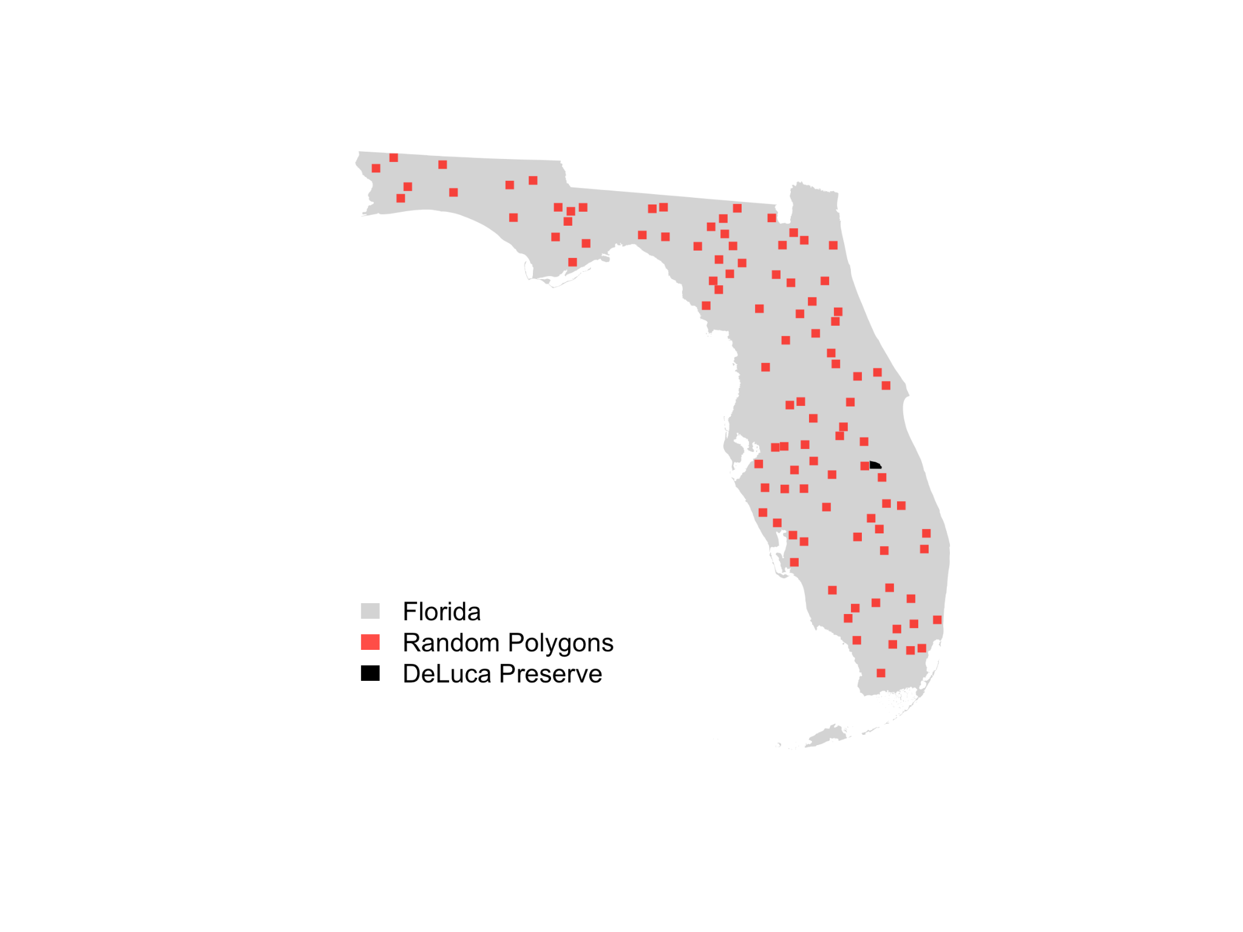
Figure S1. To determine the cumulative effort and illustrate the potential people-hours compared to other locations in Florida, we generated 100 random square boundaries with the same area as the DeLuca preserve across Florida.
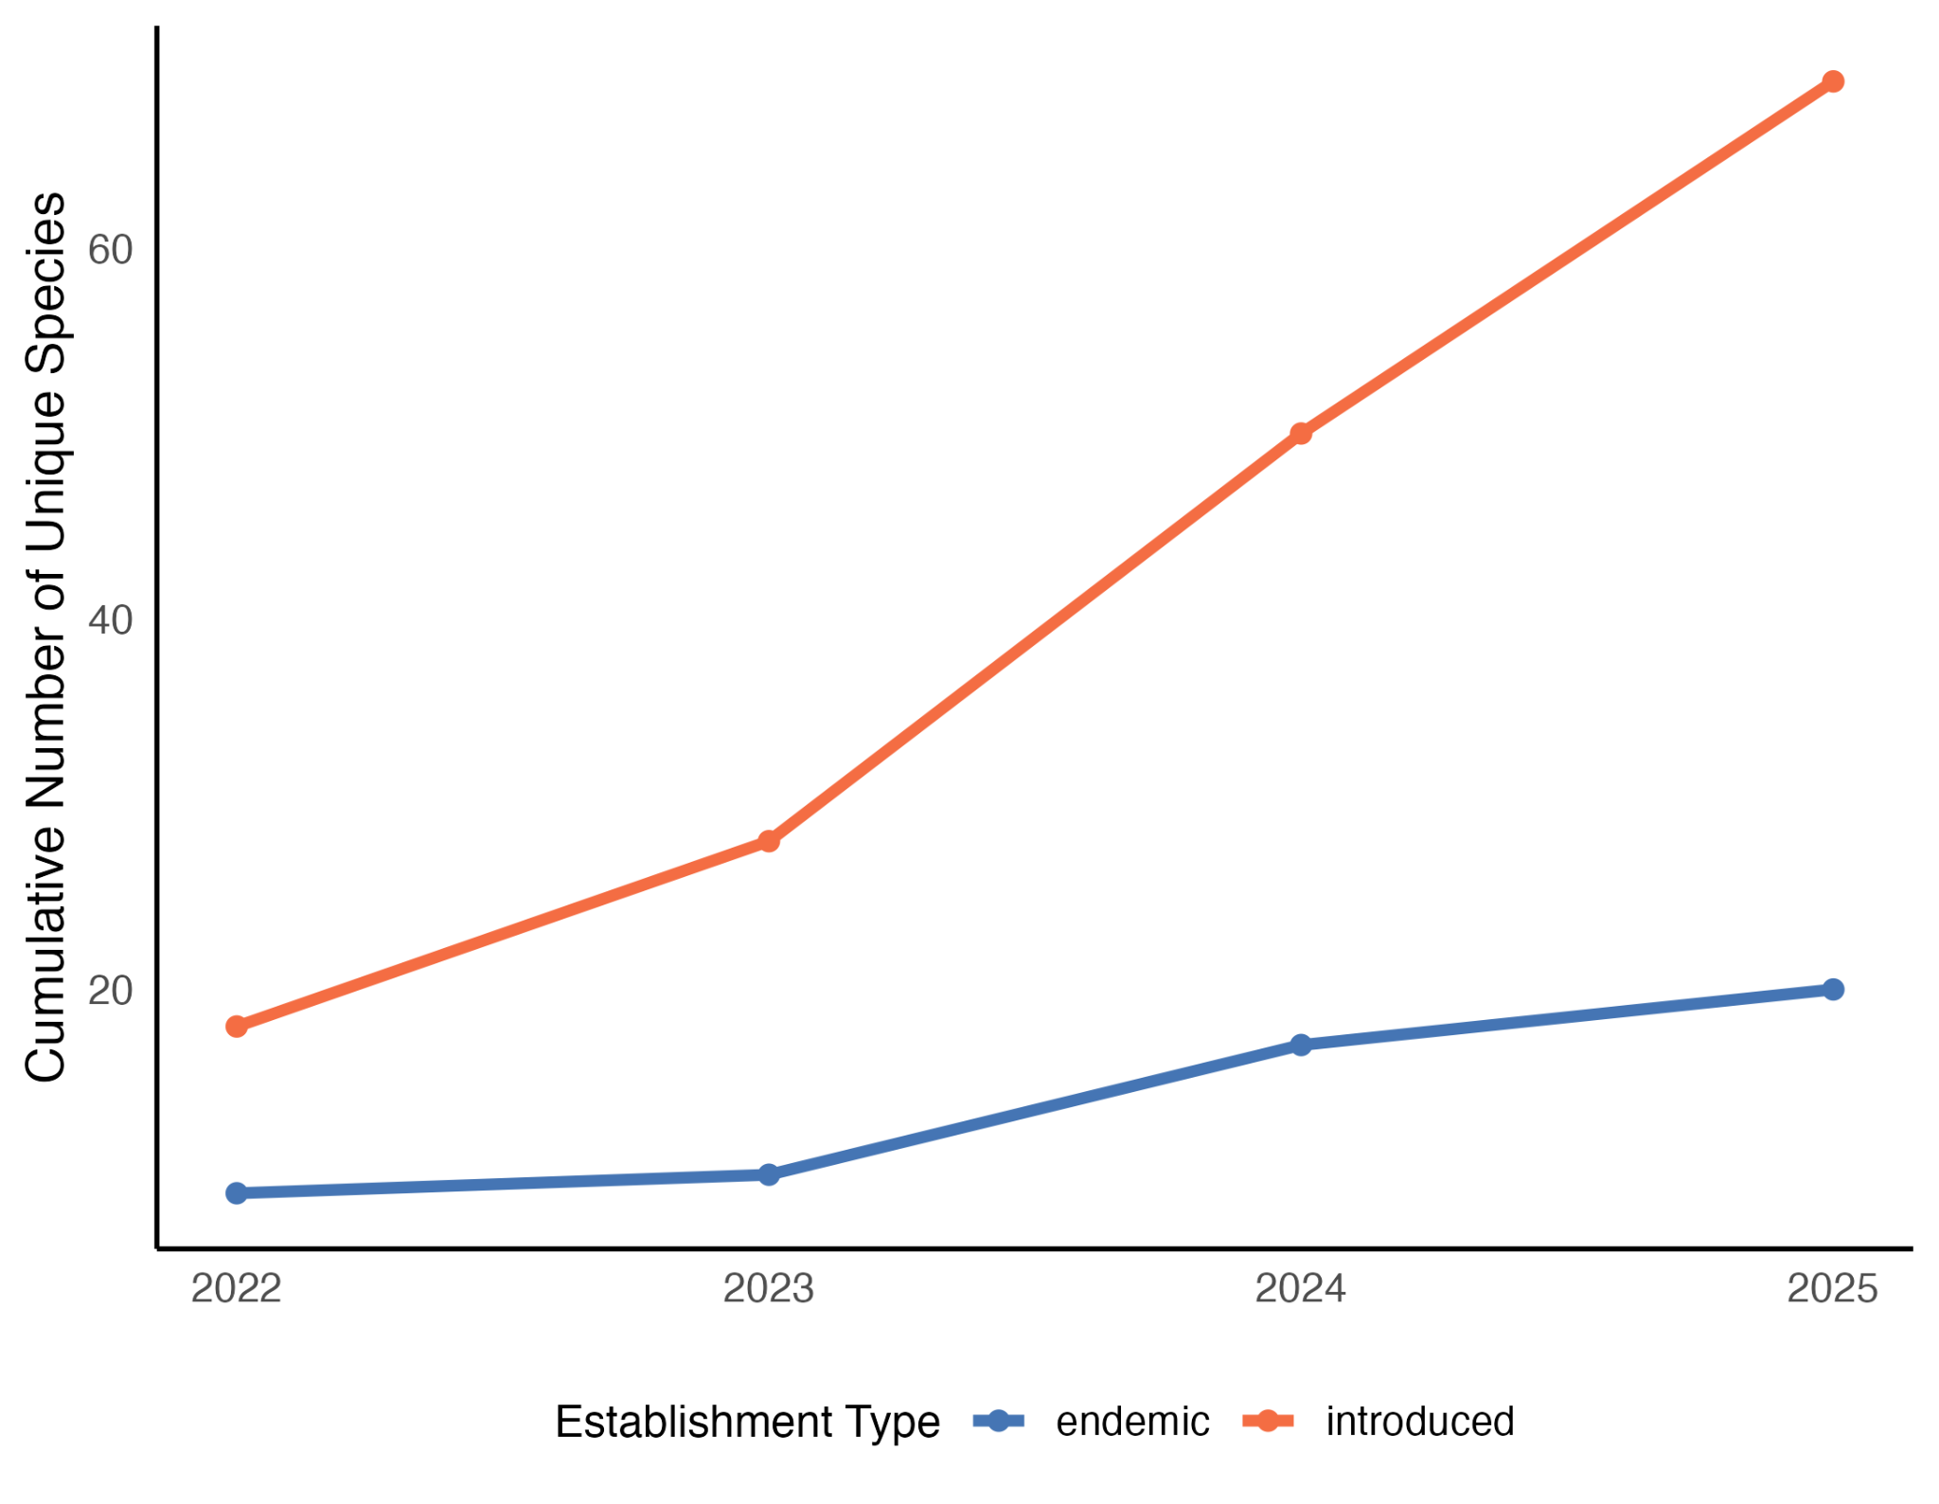
Figure S2. Cumulative number of endemic and introduced species recorded during bioblitz events at DeLuca Preserve, based on Research Grade iNaturalist observations. The orange line represents the number of introduced species over time. The blue line represents the number of endemic species to Florida over time. Both represent an increase in findings of establishment type per sampling effort.
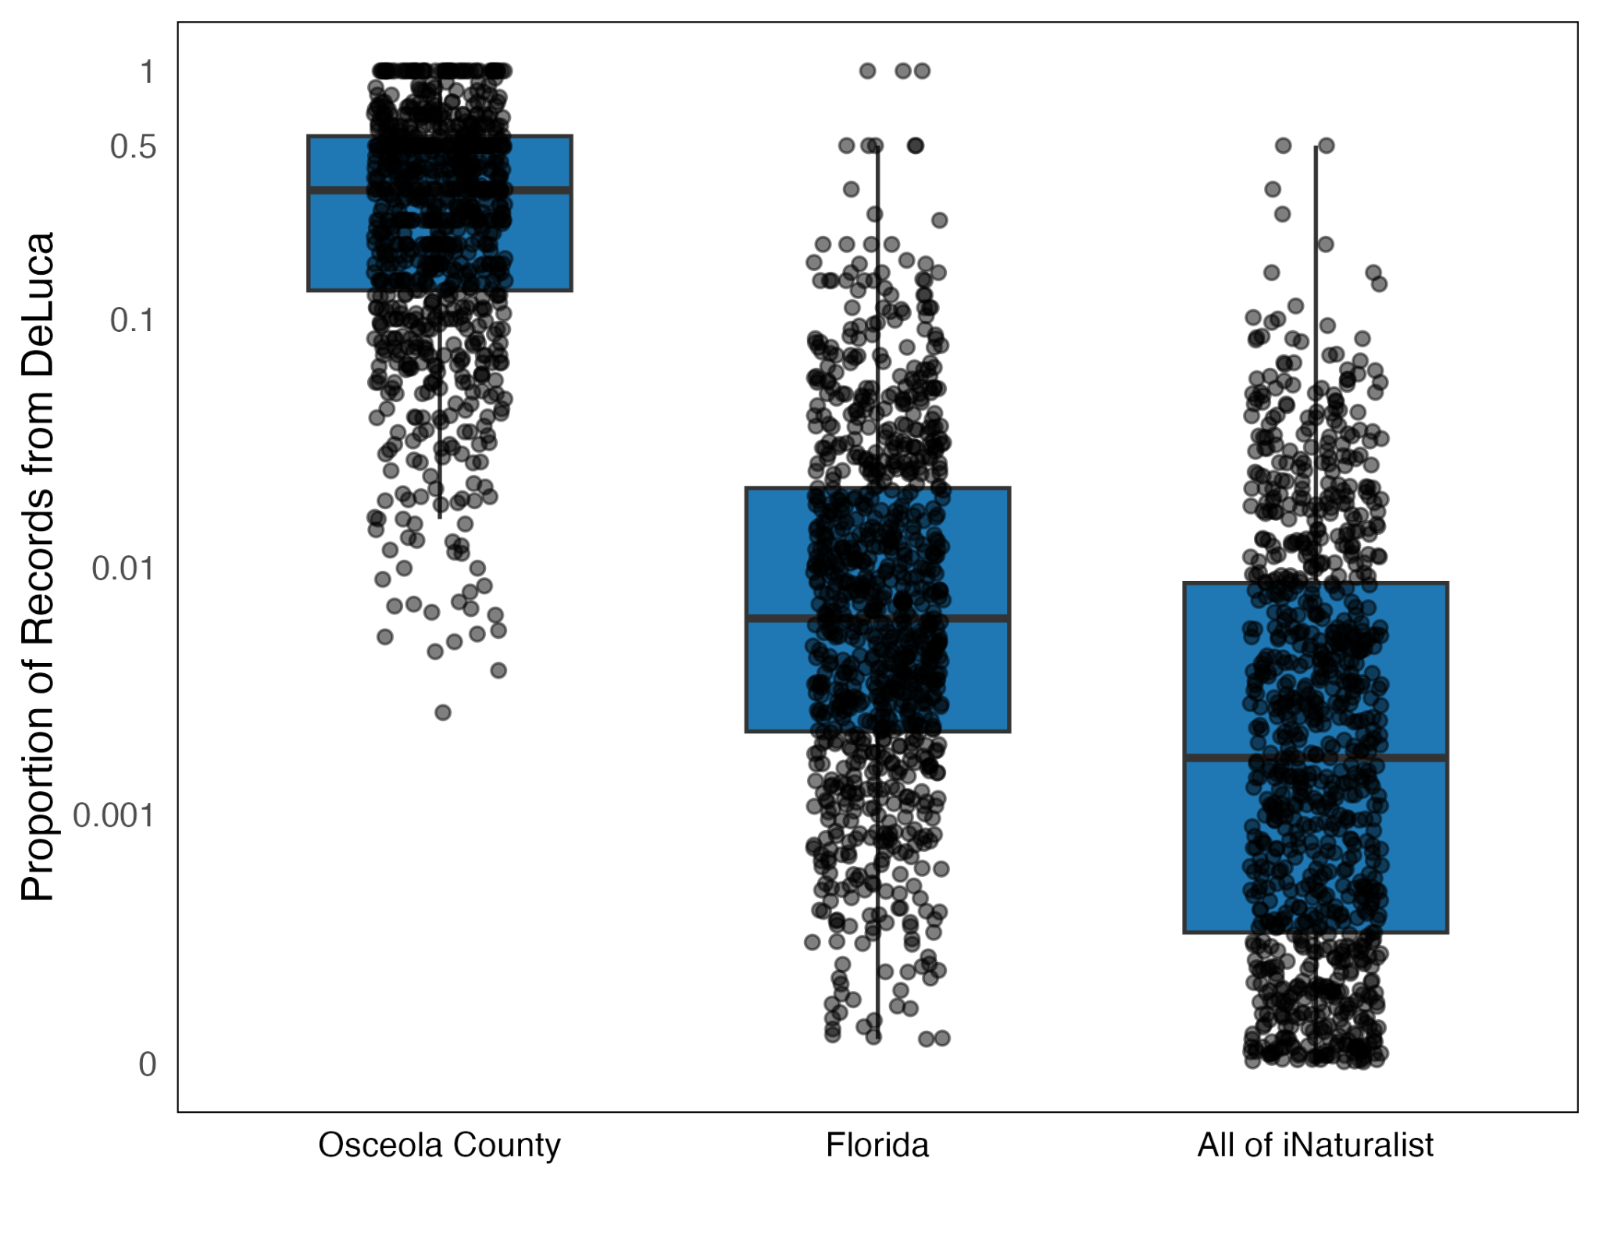
Figure S3. Proportion of all recorded observations per species that originated from the DeLuca Bioblitzes across different spatial scales. Each point represents a single species, with boxplots denoting the interquartile range. The three panels correspond to (from left to right): observations within Osceola County, all observations across Florida, and all observations on iNaturalist. All observations are Research Grade.
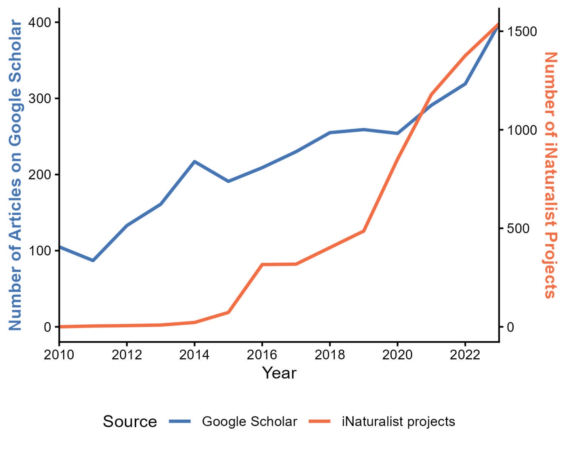
Figure S4. The blue line represents the number of articles returned from Google Scholar searches for the term “Bioblitz” by year. The orange line represents the number of iNaturalist projects that contain the term “Bioblitz” by year. Both cases illustrate the increasing popularity of bioblitzes over time.

